SIMATS ENGINEERING
ASSESSMENT TOOL 2

COURSE NAME: Database Management Systems COURSE CODE: CSA05

COURSE OUTCOME COVERED

CO2: Apply the relational model, relational algebra, SQL query structures, and views to solve database querying and data manipulation problems. (BL3, BL6)

Activity Tool : Scenario-Based Task (Medium) Assessment Tool Weightage: 20%

QUESTIONS
Q.N  o | Question | Bloom's Level
1 | A university stores student and course data in a single table. Analyze the structure and identify normalization issues, then redesign it up to 3NF | . BL4 – Analyze
2 | A company database contains employee and department details. Design appropriate SQL queries to retrieve employees working in multiple departments and justify your approach | . BL6 – Create
3 | Given a relation with multiple functional dependencies, determine the candidate keys and check whether the relation satisfies BCNF. If not, decompose it. | BL5 – Evaluate
4 | A banking system requires secure data access. Design views and constraints to ensure data security and integrity for different types of users. | BL6 – Create
5 | A sales database contains redundant data leading to anomalies. Analyze the schema and apply normalization up to 3NF or BCNF to eliminate redundancy. | BL4 – Analyze
6 | Given a dataset of customers and orders, write SQL queries using joins and subqueries to retrieve meaningful information such as frequent customers. | BL3 – Apply
7 | A relation contains multi-valued dependencies. Analyze the structure and decompose it into 4NF, explaining the reasoning. | BL4 – Analyze

8 | A database designer used improper constraints, leading to inconsistent data. Evaluate the schema and suggest appropriate integrity constraints. | BL5 – Evaluate
9 | For a given relational schema, analyze the presence of join dependencies and decompose it into 5NF to remove redundancy. | BL6 – Create
10 | A system uses inefficient SQL queries for data retrieval. Analyze the queries and optimize them using joins, indexing concepts, or query restructuring. | BL5 – Evaluate

Code of Conduct:

I Shaik mahamad sohail(192511120) certify that this submission is my original work and that I have adhered to the guidelines specified for this assessment. I understand that any violation of academic integrity rules will result in disciplinary action.

Signature of the student: 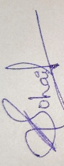

RUBRICS FOR CALCULATION:

Criteria | Level 4 (Exemplary) | Level 3 (Proficient) | Level 2 (Developing) | Level 1 (Beginning)
Understandin g of Scenario | Demonstrates clear and complete understanding of the scenario  and context | Shows good understanding with minor gaps | Partial understanding  ; misses key aspects | Misinterprets or fails to understand the scenario
Identification of Key Issues | Accurately identifies all relevant issues and factors  involved | Identifies most key issues with minor omissions | Identifies limited issues; some irrelevant  points | Unable to identify key issues
Application of Concepts | Applies appropriate concepts effectively to  address the scenario | Applies concepts with minor errors | Limited or partially correct application | Unable to apply relevant concepts
Decision Making | Makes well-reasoned,  logical decisions with strong rationale | Makes reasonable decisions with  some justification | Makes weak decisions with limited justification | No clear decisions made or  rationale provided
Clarity of Response | Response is clear, structured, and  logically presented | Generally clear with minor issues | Somewhat unclear or poorly structured | Disorganized and difficult to understand

- A university stores student and course data in a single table. Analyze the structure and identify normalization issues, then redesign it up to 3NF

ANS:

Unnormalized Table (UNF)
StudentID | StudentName | Depart-  ment | CourseID | CourseName | Faculty | FacultyPhone
S101 | sonu | CSE | C101 | DBMS | Dr.  Kumar | 9876543210
S101 | sonu | CSE | C102 | Python | Dr.  Meena | 9876543222
S102 | pranathi | ECE | C101 | DBMS | Dr.  Kumar | 9876543210

Normalization Issues
The table has the following problems:
  - Data Redundancy: Student and faculty information is repeated.
  - Update Anomaly: Changing a faculty phone number requires updating multiple rows.
  - Insertion Anomaly: A new course cannot be added until a student enrolls.
  - Deletion Anomaly: If the last student leaves a course, course information is lost.

First Normal Form (1NF)
Rule: Remove repeating groups and ensure every column contains atomic values.
Table: Student_Course
StudentID | StudentName | Department | CourseID | CourseName | Faculty | FacultyPhone
S101 | sonu | CSE | C101 | DBMS | Dr.  Kumar | 9876543210
S101 | sonu | CSE | C102 | Python | Dr.  Meena | 9876543222
S102 | pranathi | ECE | C101 | DBMS | Dr.  Kumar | 9876543210

Primary Key: (StudentID, CourseID) Second Normal Form (2NF)
Rule: Remove partial dependency.

Student Table
StudentID | StudentName | Department
S101 | sonu | CSE
S102 | pranathi | ECE
Primary Key: StudentID Course Table
CourseID | CourseName | Faculty | FacultyPhone
C101 | DBMS | Dr. Kumar | 9876543210
C102 | Python | Dr. Meena | 9876543222

Primary Key: CourseID

Enrollment Table
StudentID | CourseID
S101 | C101
S101 | C102
S102 | C101
Primary Key: (StudentID, CourseID)

Foreign Keys:
  - StudentID → Student Table
  - CourseID → Course Table

Third Normal Form (3NF)
Rule: Remove transitive dependency.

Student
StudentID | StudentName | Department
S101 | Rahul | CSE
S102 | Priya | ECE

Faculty
FacultyID | FacultyName | FacultyPhone
F101 | Dr. Kumar | 9876543210
F102 | Dr. Meena | 9876543222

Course
CourseID | CourseName | FacultyID
C101 | DBMS | F101
C102 | Python | F102
Foreign Key: FacultyID → Faculty Enrollment
StudentID | CourseID
S101 | C101
S101 | C102
S102 | C101

Foreign Keys:
  - StudentID → Student
  - CourseID → Course

Final 3NF Schema
Student(StudentID, StudentName, Department) Faculty(FacultyID, FacultyName, FacultyPhone) Course(CourseID, CourseName, FacultyID) Enrollment(StudentID, CourseID)

- A company database contains employee and department details. Design appropriate SQL queries to retrieve employees working in multiple departments and justify your approach

ANS:
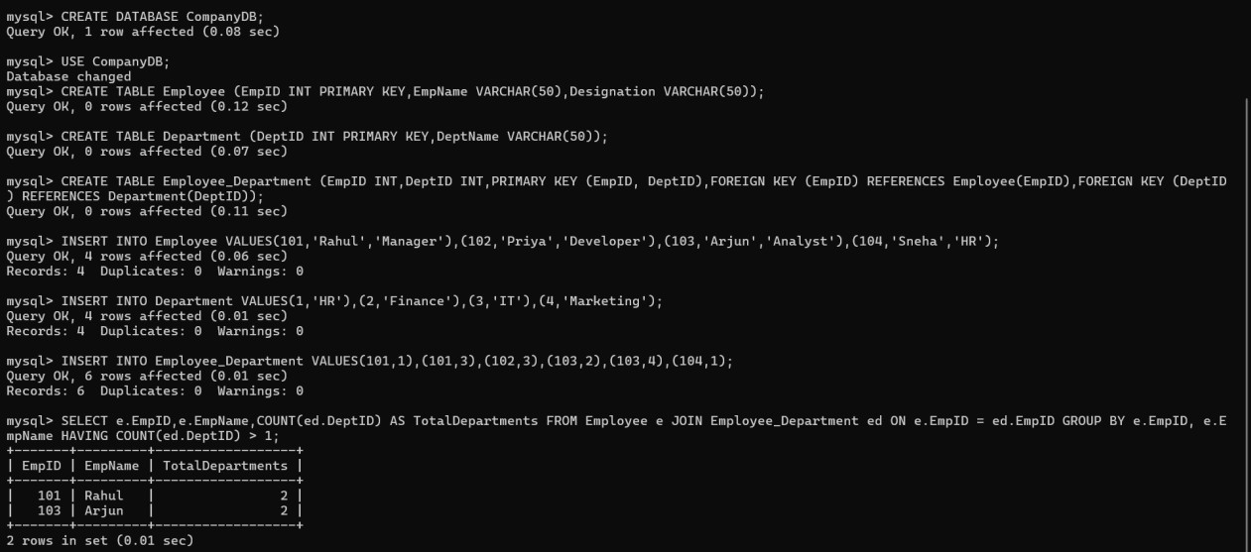

The query uses an INNER JOIN to combine the Employee and Employee_Department tables based on the common EmpID, allowing employee details to be linked with their department assignments. The GROUP BY clause groups all department records for each employee, while the COUNT() aggregate function calculates how many departments each employee is associated with. The HAVING COUNT(DeptID) > 1 condition filters the results to display only employees who work in more than one department. This approach is efficient, easy to understand, avoids duplicate records, and correctly represents the many-to-many relationship between employees and departments in a normalized database. It also provides accurate and scalable results for organizations with large datasets.

- Given a relation with multiple functional dependencies, determine the candidate keys and check whether the relation satisfies BCNF. If not, decompose it.

ANS:

Given Relation
R(StudentID, StudentName, CourseID, CourseName, FacultyID, FacultyName)

Functional Dependencies (FDs)
- StudentID → StudentName
- CourseID → CourseName, FacultyID
- FacultyID → FacultyName

Determine the Candidate Key
attribute(s) that can determine all other attributes.
  - StudentID determines only StudentName.
  - CourseID determines CourseName and FacultyID.
  - FacultyID determines FacultyName.

Therefore:
(StudentID, CourseID) determines:
  - StudentName (from StudentID)
  - CourseName (from CourseID)
  - FacultyID (from CourseID)
  - FacultyName (from FacultyID)

Candidate Key = (StudentID, CourseID) Check BCNF

BCNF Rule:
For every functional dependency X → Y, X must be a superkey.
Functional Dependency | Is Left Side a Superkey? | BCNF
StudentID → StudentName | No | Violates BCNF
CourseID → CourseName, FacultyID | No | Violates BCNF
FacultyID → FacultyName | No | Violates BCNF
Since the determinants (StudentID, CourseID, and FacultyID) are not superkeys, the relation does not satisfy BCNF.

BCNF Decomposition Student Table
StudentID (PK) | StudentName
S101 | Rahul
S102 | Priya

Faculty Table
FacultyID (PK) | FacultyName
F101 | Dr. Kumar
F102 | Dr. Meena

Course Table
CourseID (PK) | CourseName | FacultyID (FK)
C101 | DBMS | F101
C102 | Python | F102

Enrollment Table
StudentID (FK) | CourseID (FK)
S101 | C101
S101 | C102
S102 | C101
Primary Key: (StudentID, CourseID) Final BCNF Schema Student(StudentID, StudentName) Faculty(FacultyID, FacultyName)
Course(CourseID, CourseName, FacultyID) Enrollment(StudentID, CourseID)

Conclusion
The original relation violated BCNF because some functional dependencies had determinants that were not superkeys. By decomposing the relation into Student, Faculty, Course, and Enrollment tables, every determinant becomes a key in its respective relation. This removes redundancy, prevents update anomalies, and ensures the database satisfies Boyce-Codd Normal Form (BCNF).

A banking system requires secure data access. Design views and constraints to ensure data security and integrity for different types of users.
ANS:
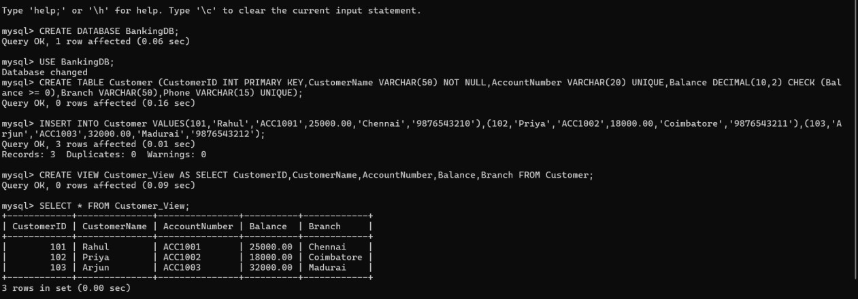

Constraints Used
Constraint | Purpose
PRIMARY KEY | Ensures each customer has a unique CustomerID.
NOT NULL | Prevents CustomerName from being empty.
UNIQUE | Prevents duplicate AccountNumber and Phone values.
CHECK | Ensures the account balance is never negative.

Justification of the Approach
The solution uses database views to provide secure access by displaying only the information required by different users while hiding sensitive data such as customer phone numbers. This improves confidentiality and reduces the risk of unauthorized access. Integrity constraints such as PRIMARY KEY, NOT NULL, UNIQUE, and CHECK maintain data accuracy and consistency by preventing duplicate records, null values in mandatory fields, invalid account balances, and incorrect customer information. Together, views and constraints improve database security, enforce business rules, and maintain data integrity in the banking system.

- A sales database contains redundant data leading to anomalies. Analyze the schema and apply normalization up to 3NF or BCNF to eliminate redundancy

ANS:

Unnormalized Relation (UNF) Sales
Or der  ID | Custo merI  D | Custom erNam  e | Pro duct  ID | Produ ctNam  e | Supp lierI  D | Suppli erNam  e | Qu anti  ty
O1  01 | C101 | Rahul | P101 | Laptop | S101 | Dell | 2
O1  01 | C101 | Rahul | P102 | Mouse | S102 | Logitec  h | 1
O1  02 | C102 | Priya | P101 | Laptop | S101 | Dell | 1

Problems in the Schema
The table contains the following anomalies:
  - Data Redundancy: Customer, product, and supplier details are repeated.
  - Update Anomaly: Updating a supplier or customer name requires changes in multiple rows.
  - Insertion Anomaly: A new product or supplier cannot be added unless an order exists.
  - Deletion Anomaly: Deleting the last order of a product removes the product and supplier information.

First Normal Form (1NF)
Rule: Remove repeating groups and ensure all attributes contain atomic values. The relation already satisfies 1NF because each column contains a single value.

Second Normal Form (2NF)
Rule: Remove partial dependencies. Customer Table
CustomerID (PK) | CustomerName
C101 | Rahul
C102 | Priya

Supplier Table
SupplierID (PK) | SupplierName
S101 | Dell
S102 | Logitech

Product Table
ProductID (PK) | ProductName | SupplierID (FK)
P101 | Laptop | S101
P102 | Mouse | S102

Sales Table
OrderID | CustomerID (FK) | ProductID (FK) | Quantity
O101 | C101 | P101 | 2
O101 | C101 | P102 | 1
O102 | C102 | P101 | 1

Third Normal Form (3NF)
The transitive dependency has been removed by separating Supplier information from Product.
Final 3NF Schema Customer(CustomerID, CustomerName) Supplier(SupplierID, SupplierName)
Product(ProductID, ProductName, SupplierID) Sales(OrderID, CustomerID, ProductID, Quantity)

Final Tables Customer
CustomerID | CustomerName
C101 | Rahul
C102 | Priya

Supplier
SupplierID | SupplierName
S101 | Dell
S102 | Logitech

Product
ProductID | ProductName | SupplierID
P101 | Laptop | S101
P102 | Mouse | S102

Sales
OrderID | CustomerID | ProductID | Quantity
O101 | C101 | P101 | 2
O101 | C101 | P102 | 1
O102 | C102 | P101 | 1

Conclusion
The original sales database contained redundancy and suffered from update, insertion, and deletion anomalies. After normalization to 3NF, customer, supplier, product, and sales information are stored in separate tables with proper relationships. This eliminates redundancy, improves data integrity, and makes the database easier to maintain.

- Given a dataset of customers and orders, write SQL queries using joins and subqueries to retrieve meaningful information such as frequent customers.

ANS:
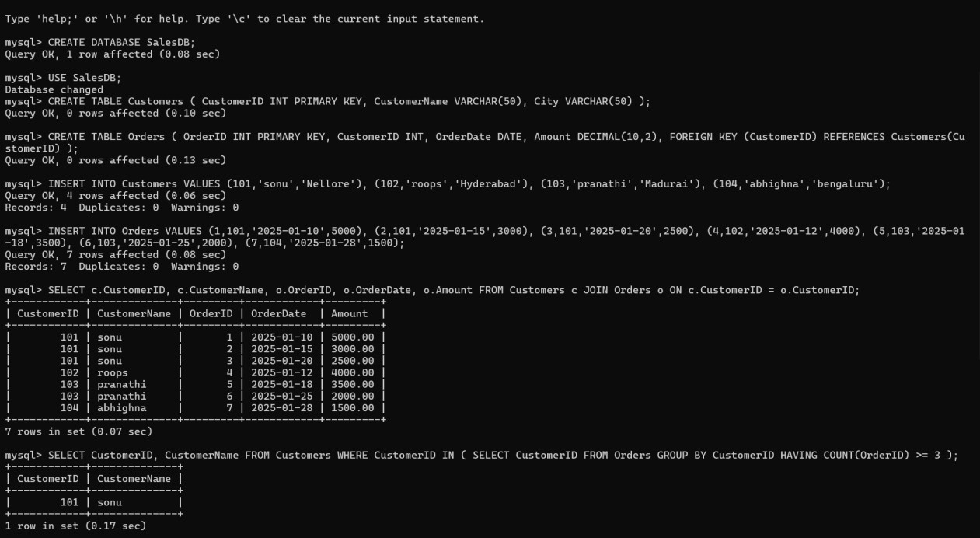
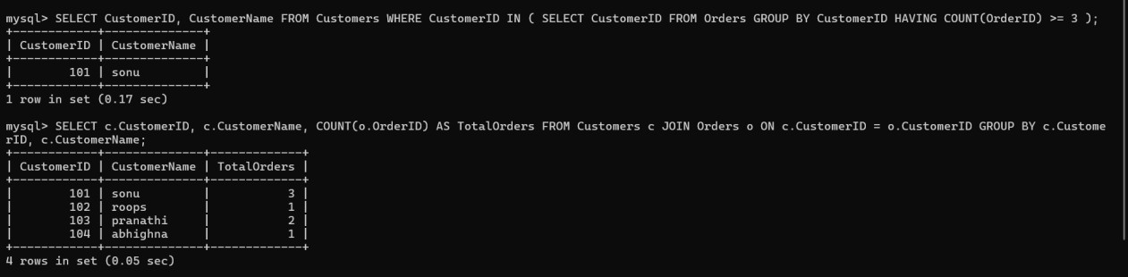

- A relation contains multi-valued dependencies. Analyze the structure and decompose it into 4NF, explaining the reasoning.

ANS:

Given Relation
R(StudentID, StudentName, Course, Hobby) Sample Data
StudentID | StudentName | Course | Hobby
S101 | Rahul | DBMS | Cricket
S101 | Rahul | DBMS | Music
S101 | Rahul | Python | Cricket
S101 | Rahul | Python | Music

S102 | Priya | Java | Reading
S102 | Priya | Java | Dance

Identify the Multi-Valued Dependencies (MVDs)
A student can enroll in multiple courses and can also have multiple hobbies, where courses and hobbies are independent of each other.
The multi-valued dependencies are:
- StudentID →→ Course
- StudentID →→ Hobby
Since these are independent multi-valued attributes, the relation contains multi-valued dependencies, leading to unnecessary repetition of data.

Problems in the Relation
The relation suffers from:
- Data Redundancy: Course and hobby information is repeated.
- Update Anomaly: Updating a hobby or course requires changes in multiple rows.
- Insertion Anomaly: Adding a new hobby requires repeating course information.
- Deletion Anomaly: Deleting a course may unintentionally remove hobby information.

Decompose into 4NF Student Table
StudentID (PK) | StudentName
S101 | Rahul
S102 | Priya

Student_Course Table
StudentID (FK) | Course
S101 | DBMS
S101 | Python
S102 | Java

Student_Hobby Table
StudentID (FK) | Hobby
S101 | Cricket
S101 | Music
S102 | Reading
S102 | Dance

Final 4NF Schema Student(StudentID, StudentName) Student_Course(StudentID, Course) Student_Hobby(StudentID, Hobby)

- A database designer used improper constraints, leading to inconsistent data. Evaluate the schema and suggest appropriate integrity constraints

ANS:
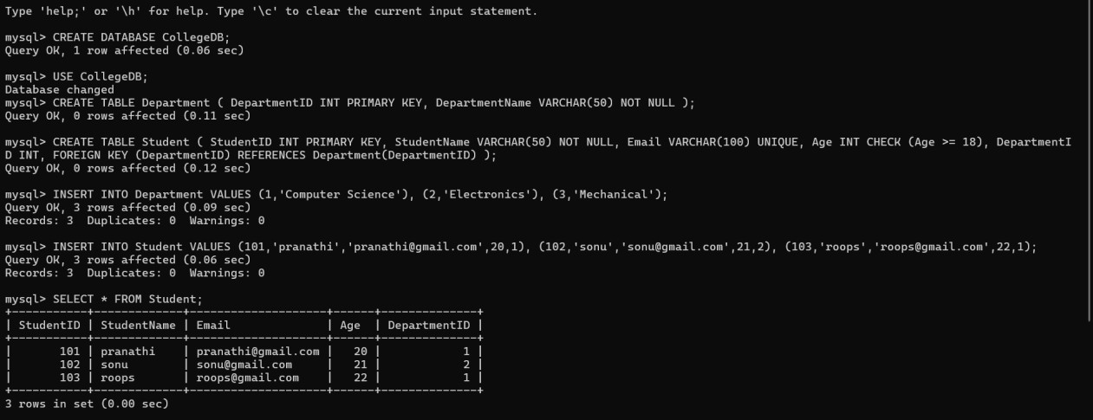

Evaluation of the Schema
The existing database schema does not enforce proper integrity constraints, which can result in inconsistent and invalid data. The following issues may occur:
  - Duplicate StudentID values may be inserted.
  - StudentName may be left empty (NULL).
  - Duplicate email addresses can exist for multiple students.
  - Invalid age values (such as negative numbers or ages below the allowed limit) may be entered.
  - A student may be assigned to a DepartmentID that does not exist in the Department table, causing referential integrity problems.
These issues lead to inaccurate, inconsistent, and unreliable data.

Suggested Integrity Constraints
Constraint | Purpose
PRIMARY KEY | Ensures each student has a unique StudentID and prevents NULL  values.
NOT NULL | Ensures mandatory fields such as StudentName and DepartmentName  are not left empty.
UNIQUE | Prevents duplicate values in fields such as Email or Account Number.
CHECK | Restricts values to a valid range (e.g., Age >= 18 or Balance >= 0).
FOREIGN KEY | Ensures that DepartmentID exists in the Department table, maintaining  referential integrity.
DEFAULT  (optional) | Assigns a default value if no value is provided (e.g., Status = 'Active').

- For a given relational schema, analyze the presence of join dependencies and decompose it into 5NF to remove redundancy

ANS:

Given Relation
R(SupplierID, PartID, ProjectID)

Sample Data
SupplierID | PartID | ProjectID
S1 | P1 | J1
S1 | P2 | J1
S2 | P1 | J2
S2 | P2 | J2

This relation stores which supplier supplies which part to which project. Analyze Join Dependency
A join dependency (JD) exists when a relation can be reconstructed by joining multiple smaller relations without losing information.
In this relation:
- A supplier supplies multiple parts.
- A supplier works on multiple projects.
- A part can be used in multiple projects. Thus, the relation has a join dependency:

R(SupplierID, PartID, ProjectID)
can be reconstructed from:
- R1(SupplierID, PartID)
- R2(SupplierID, ProjectID)
- R3(PartID, ProjectID)
The original relation contains redundant combinations of supplier, part, and project.

Problems in the Relation The relation suffers from:
- Data Redundancy: The same supplier, part, and project combinations are stored repeatedly.
- Update Anomaly: Updating supplier, part, or project information requires changes in multiple rows.
- Insertion Anomaly: New supplier-part or supplier-project relationships cannot be added independently.
- Deletion Anomaly: Deleting one record may remove important relationship information.

Decompose into 5NF Supplier_Part
SupplierID | PartID
S1 | P1
S1 | P2
S2 | P1
S2 | P2

Supplier_Project
SupplierID | ProjectID
S1 | J1
S2 | J2

Part_Project
PartID | ProjectID
P1 | J1
P2 | J1
P1 | J2
P2 | J2

Final 5NF Schema Supplier_Part(SupplierID, PartID) Supplier_Project(SupplierID, ProjectID) Part_Project(PartID, ProjectID)

A system uses inefficient SQL queries for data retrieval. Analyze the queries and optimize them using joins, indexing concepts, or query restructuring.

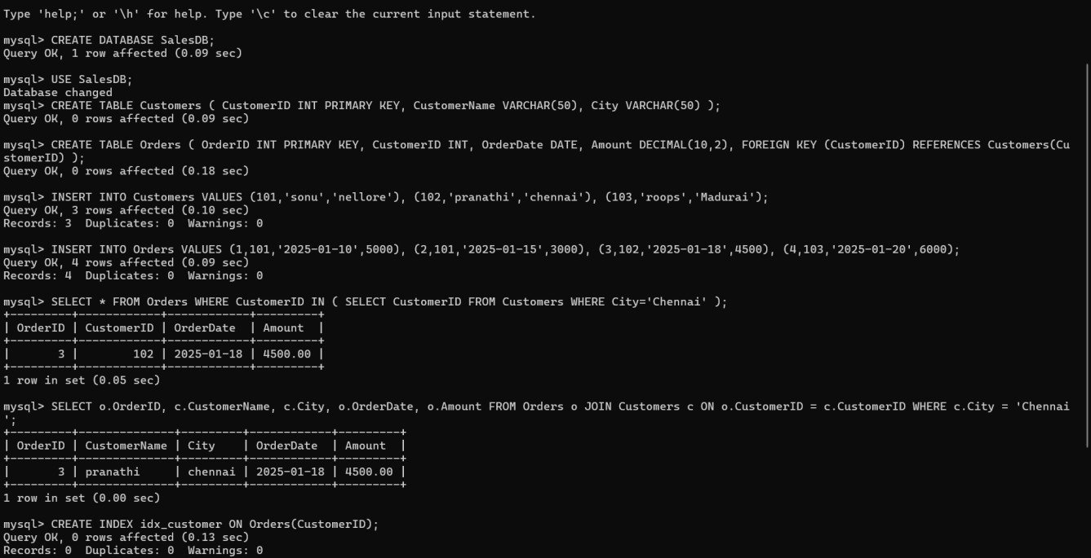
ANS:

Analysis of the Queries
The original query uses a subquery with the IN operator to retrieve customer records. Although it returns the correct result, it can be less efficient when the database contains a large number of records because the subquery must first retrieve matching CustomerID values before the outer query is executed.
The optimized query replaces the subquery with an INNER JOIN, allowing the database to retrieve matching records directly from both tables. Most database management systems optimize JOIN operations more effectively than nested subqueries, resulting in faster

execution and better performance.
An index is created on the CustomerID column of the Orders table. The index speeds up searching, filtering, and joining by allowing the database engine to locate matching records quickly instead of scanning the entire table.

Optimization Techniques Used

JOIN
  - Replaced the nested subquery with an INNER JOIN.
  - Retrieves related data more efficiently.

Indexing
  - Created an index on CustomerID.
  - Improves search and join performance.

Query Restructuring
  - Simplified the SQL statement.
  - Reduced unnecessary processing.
  - Improved readability and scalability.

